Choose 10 of these questions to put into your company’s survey. Adjust the question, scale, or wording to fit your company’s service and or products.
- How often do you use the product or service?
- Does the product help you achieve your goals?
- What is your favorite tool or portion of the product or service?
- What would you improve if you could?
- How old are you?
- Where are you located?
- If applicable, what gender do you identify as?
- What is your employment status?
- What is your marital status and do you have children?
- A scale measuring from 1 to 10 (or another number). 1 is an extremely unsatisfied opinion and 10 meaning the customer was very satisfied.
- A descriptive scale that measures a customer's response from unsatisfied to satisfied. The customer is a given a short list of responses to choose from that range from "very unsatisfied" to "very satisfied."
- A picture scale that uses images to symbolize customer satisfaction. For example, you can use happy, sad, and indifferent emojis to quickly communicate customer feedback.
- In your own words, describe how you feel about (insert company name or product here).
- How can we improve your experience with the company?
- What's working for you and why?
- What can our employees do better?
- Do you have any additional comments or feedback for us?
- May we contact you to follow up on these responses?
- In the future, would you be willing to take this survey again?
- If we were to update (insert product feature here), could we reach back out to talk about these changes?
- Which of the following words would you use to describe our product?
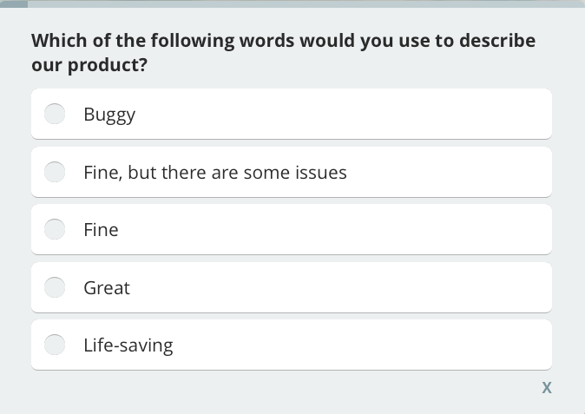
(Give different describing words that you could apply to your products or services) EXAMPLE

- How well does our product meet your needs?
- Which 3 features are the most valuable to you?
- What are the 3 most important features we’re missing?
- If you could change just one thing about our product, what would it be?
- How easy is it to navigate our website?
- Were you able to find the information you were looking for on our website?
- Compared to our competitors, is our product quality better, worse, or about the same?
- Which other options did you consider before choosing our product?
- On a scale of 1-10 how likely are you to recommend our product/service to a friend/ family member?

