Please read directions all the way through.
You are now creating a party from the ground up! The teacher gives you little to nothing, just a list of requirements! You will be working by yourself to plan whatever type of party you choose. Your budget is $10,000.
** YOU NEED TO SPEND AS MUCH OF THE $10,000 WITHOUT GOING OVER**
**YOU WILL BE REQUIRED TO USE EQUATIONS FOR YOUR TOTAL COSTS OF ITEMS AND OVERALL COST. Typed in numbers for TOTALS will be points deducted.
Late work is automatic 10% each school day it is late.
Duplicated/copied work is an automatic 0 for both people.
If you are absent you are allowed to come in during PE or Lunch to complete your work.
The Client List of Requirements:
- Between 100-200 people.
- A Place to hold the event.
- Someone to provide music. (If you are not hiring a person such as band or DJ you need to purchase something to make the music such as a laptop, speakers etc.)
- Food for Everyone. (Must be a complete meal.)
- A way to record memories from the event (Photographer, Videographer, Cameras etc.)
- Drinks (NON-Alcoholic) for every guest.
- Tables to accommodate all guests (Think about how many people you want at a table.)
- Chairs for every guests to sit at the tables.
- Decorations of some sort. (Posters, Ice Sculptures, Balloons, Piñata, Statues, Special lighting, etc.)
- Gift Bags (Party Favors) for every guest. (Bag and contents sold separately unless buying a fully stocked bag.)
EXAMPLE 1:
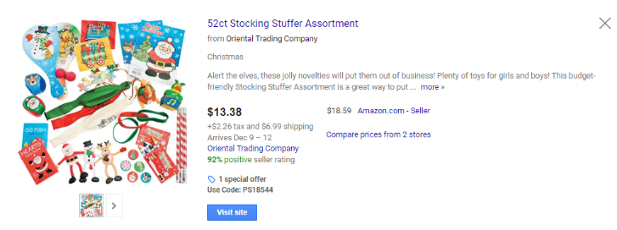

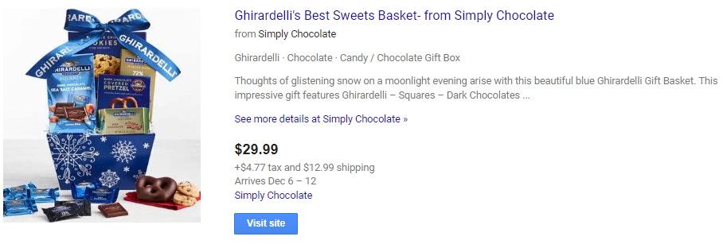
EXAMPLE 2:

- A new outfit for the occasion.
It is now your job to look up locations where you want to hold this party. Someone’s house for Having someone such as family or friends do something for free such as DJ, Making Clothing, Making Decorations etc, IS NOT ALLOWED.
Because you are now choosing the location you still have to READ THE DESCRIPTION OF EVERYTHING THAT IS PROVIDED FIRST and then fill in the gaps. If you are unable to find exact prices for locations, you might have to look up similar venues and get an average cost. If you cannot find a similar location, you will have to find a new website or location for your event.
Party Requirements
Food for Main Meal | Cost
Drinks for everyone | Cost
Music | Cost
Gift Bags (Include what you are putting in the bag as well as the cost of the bags) | Cost
Photographer (Takes Pictures) | Cost
Videographer (Takes Video) | Cost
Dessert | Cost
The Venue List of Requirements (Even if staff is included I still require these people to be hired):
- At least 1 a cook.
- At least 1 waiter.
- At least 1 person to clear the tables.
**For each worker you hire there is a 10% tip that you Must include.
Workers | Cost
Anna the Chef | $800
Jose the Chef | $500
Michelle the Chef | $650
Bob the Waiter | $150
Katrina the Waiter | $200
Marco the Waiter | $100
Charlie the Bus Girl | $100
Harry the Bus Boy | $150
Lisa the Bus Girl | $125

The Outfit List of Requirements:
- USING: Google.com/shopping ONLY you will find the outfit for your client
- You Must Include Pictures (screen shots) WITH PRICE INCLUDED
- Outfits must be complete (take gender of host into consideration.)
  - Shirts
  - Pants
  - Socks
  - Shoes
  - Dress
  - Jewelry/accessories
  - Purse
  - Make-up
  - Cologne (men’s body spray)
  - Belt
Locations you can find online and check out how much it would costs to rent/buy for a day.
EXAMPLES OF LOCATIONS TO HOLD THE PARTY:
- ANY Hotel
- Old Tucson
- A Church (Or another religious location, Synagogue, Mosque…)
- ANY Golf Course
- Banquet Hall
- The Zoo (Reid Park, Phoenix, San Diego)
- Aquarium
- Water Park
- Amusement Park
- Funtasticks
- Golf n Stuff
- Top Golf
- A Party Bus
- A Sports park or arena (box seats/Private room at a football, basketball, baseball, volleyball, soccer, or hockey game)
- The Mall
- A Restaurant (Chucky Cheese, Peter Piper, Olive Garden, anywhere you’d like…)
We will have 2 check in days for this assignment. If you require more time due to absences please talk to your teachers and negotiate coming in during PE with Ms. K or if your teacher is willing to come in at lunch.

