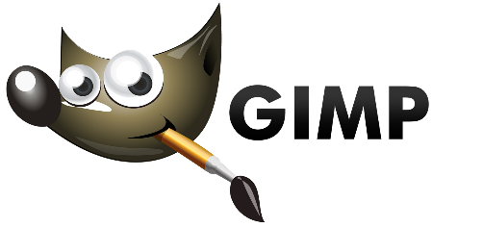
TOOL LIST
Icon | Tool Name | Keyboard Shortcut | Function of the tool
 | Rectangle | R
 | Ellipse | E
 | Free (Lasso) | F
 | Fuzzy (Magic Wand) | U
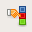 | By Color | Shift + O
 | Create Layer | None
 | Discard Layer | None
Brush tools
 | Bucket Fill | Shift + B
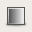 | Blend (Gradient) | L
 | Pencil | N
 | Paintbrush | P
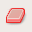 | Eraser | Shift + E
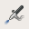 | Airbrush | A
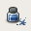 | Ink | K
 | Clone | C
 | Heal | H
 | Perspective Clone | (none)
 | Convolve (Blur/Sharpen) | Shift + U
 | Smudge | S
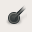 | Dodge/Burn | Shift + D
Transform tools
 | Move | M
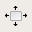 | Align | Q
 | Crop | Shift + C
 | Rotate | Shift + R
 | Scale | Shift + T
 | Shear | Shift + S
 | Perspective | Shift + P
 | Flip | Shift + F
Color tools
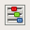 | Color Balance | (none)
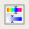 | Hue-Saturation | (none)
 | Colorize | (none)
 | Brightness-Contrast | (none)
 | Threshold | (none)
 | Levels | (none)
 | Curves | (none)
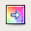 | Posterize | (none)
 | Desaturate | (none)
Other tools
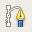 | Path | B
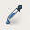 | Color Picker | O
 | Magnify (Zoom) | Z
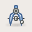 | Measure | Shift + M
 | Text | T

