Using Publisher and choosing any single page template, you will be making an invitation to an event. You can see some examples below of different styles of invitations/RSVPs
REQUIREMENTS:
- Host Name
- Date of the Event
- Time of the Event
- Location the Event is being held at
- Appropriate picture that goes along with the event
- Include what people should wear: casual, formal, black-tie, bathing suits, togas etc.
- Include a place to RSVP (Répondez s'il vous plaît,) meaning "Please respond"
- Who are they responding to?
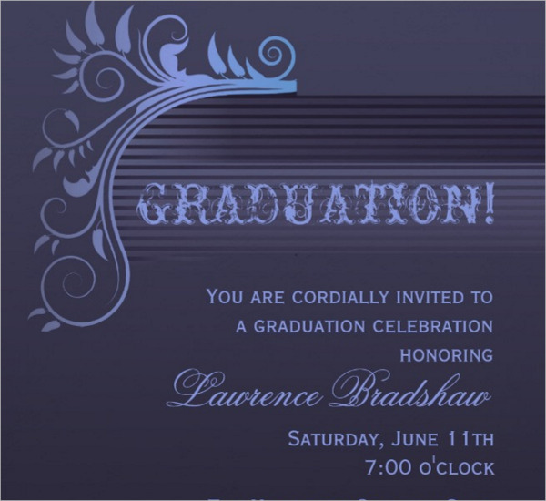
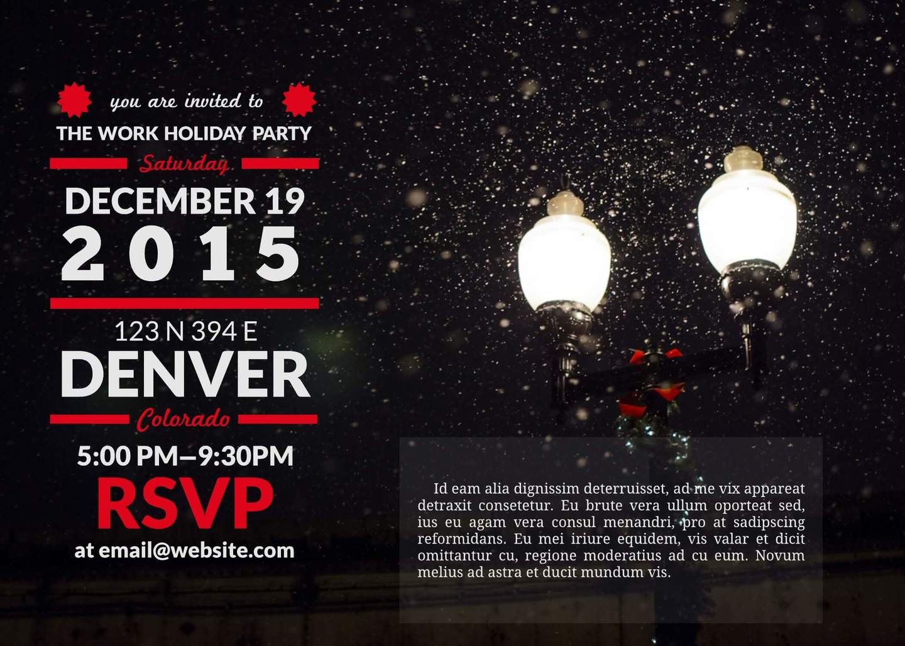
- How are they supposed to get ahold of this person (mailing address, email, phone number etc.)

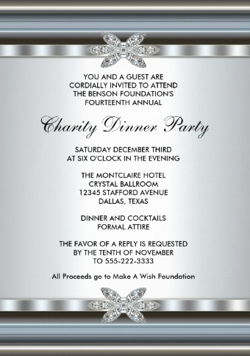
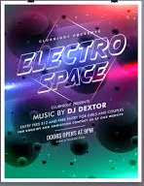
CATEGORY | (10) Excellent | (8) Good | (6) Almost | (4) Not Yet | TOTAL
Attractiveness & Organization  - Host Name  - Date of the Event  - Time of the Event  - Location the Event is being held at  - Appropriate picture that goes along with the event  - Include what people should wear: casual, formal, black-tie, bathing suits, togas etc.  - Include a place to RSVP (Répondez s'il vous plaît,) meaning "Please respond"  - Whom are they responding to?  - How are they supposed to get ahold of this person | The Invitation has exceptionally attractive and well organized.  - All 9 requirements fulfilled. | The Invitation was somewhat attractive, but there were a few spelling and organization errors.  - Between 6-7 Requirements fulfilled. | The Invitation was not very attractive or well organized. There were many errors in spelling and missing information.  - Between 3-5 Requirements fulfilled. | The Invitation was not very attractive/mostly blank.  - Less than 3 Requirements fulfilled.

