Name: _____ _________________________
Logo Design
This section is designed to help you understand the vocabulary used when creating a logo for your business.

Vocabulary | Definition
Wordmark (Text)
Lettermark (Initials)
Brandmark (Symbol or Icon)
Combination Mark (Text and Symbol)
Emblem (Text inside Symbol)
Questions
- Why did these three companies choose these kinds of logos?
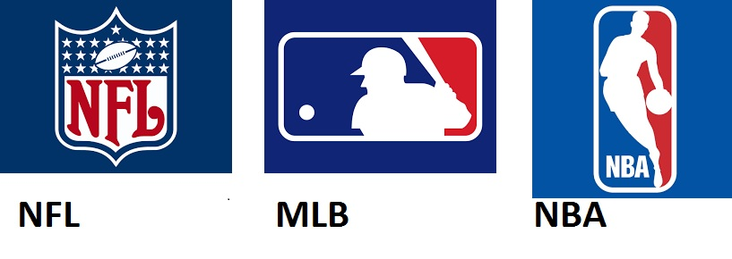
OR
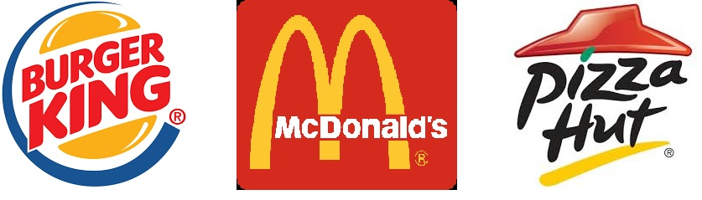
- Do you see any similarities or trends going on between these logos? If so, what are they?
- Which program will be most effective to create your logo?
- How will you represent your business effectively and give your customers a visual representation of your business?
Drawn Logo:

