Name__________________________ Teacher Name_________________________
WORD TOOL LIST
Home tab
Icon | Tool Name | Keyboard Shortcut | Function of the tool
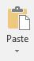
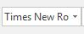
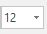
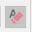
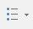
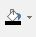
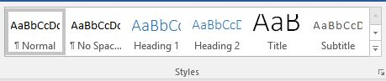
Insert Tab
