Design Tab
Icon | Tool Name | Section Name | Function of the tool
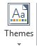
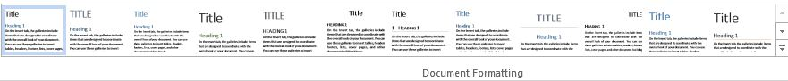
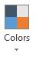
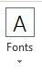
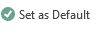
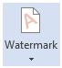
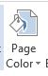
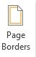
Page Layout
