You are making your dream bedroom using http://roomtodo.com. You will be creating an account using your own email address and password which you will write down on the “Password/ Log in Sheet” in your folder.
Requirements for your dream bedroom: The room cannot be larger than 20ft X 20ft. It must be a FULL room, no open walls to the outside. You are permitted to paint the walls with anything you would like through the website. The floors can be anything available to you through the website. You are allowed to have any electronics/art/ appropriate decorations the website offers.
TO SUBMIT ASSIGNMENT: You must take screenshots of your bedroom from multiple angles including the Construction Mode, which will show the measurements of your room, One (1) screenshot in 2D Mode, and Two (2) in 3D Mode. Put screenshots into a Word document and submit via Edmodo.

Construction:

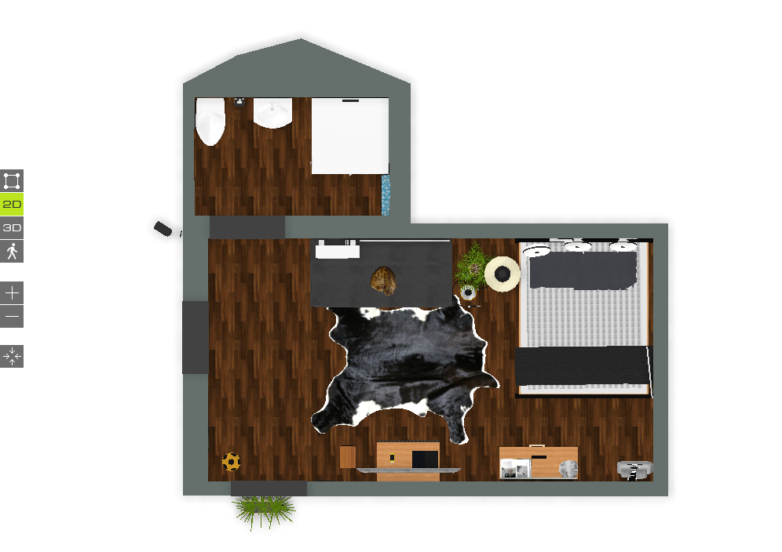
2D Mode:

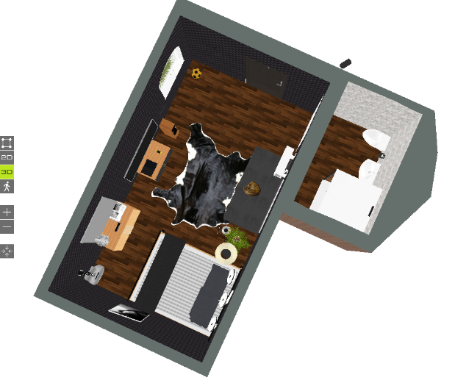
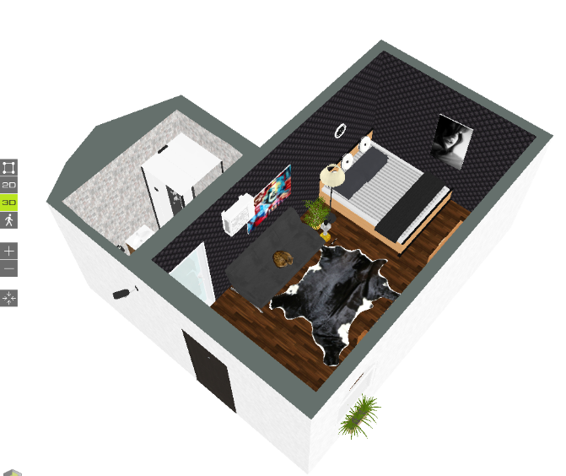
3D Mode:

MUST HAVES FOR A BEDROOM:
Bed
Dresser
At least 1 Door
At least 1 window
Closet/clothing storage of some sort (dresser/more cabinets/etc.)
At least 1 Desk
At least 1 Chair
Wall covering of some sort (paint, wallpaper, texture, etc.)
Floor covering of some sort (carpet, concrete, wood, grass, etc.)
Decorations on the wall of any sort
Some form of entertainment (computer, TV, radio, sound system, etc.)
ALLOWED OPTIONS:
Bathroom
Walk in closet (resembling a room)
Fireplace
Sitting/Reading area/ Social area
Balcony
Pets
NOT ALLOWED:
Kitchen (this is a bedroom not a loft; I will take points off for not following instructions.)
Indoor Pool (again this is a bedroom, please be practical.)
TO SIGN IN:
USERNAME:
PASSWORD:
TO SAVE:
DUE: 2/15. All late work will be 10% off.

CATEGORY | (10) Excellent | (8) Good | (5) Almost | (1) Not Yet
Attractiveness & Organization | The Project looks clean and well put together. The room is easily identifiable as a bedroom. Colors are attractive do not clash with furniture/walls/floors/etc. | The Project is somewhat clean. The room looks like it could possibly be a bedroom. Colors clash a little bit but not too much with furniture/walls/floors/etc. | The Project is not clean at all. It is hard to tell the room is supposed to be a bedroom. The colors make the room difficult to look at on the furniture/walls/floors/etc. | Room is incomplete, most items are missing and it does not look like a bedroom at all.
Content – Accuracy  MUST HAVES FOR A BEDROOM:  - Bed  - Dresser  - At least 1 Door  - At least 1 window  - Closet/clothing storage of some sort (dresser/more cabinets/etc.)  - At least 1 Desk  - At least 1 Chair  - Wall covering of some sort (paint, wallpaper, texture, etc.)  - Floor covering of some sort (carpet, concrete, wood, grass, etc.)  - Decorations on the wall of any sort  - Some form of entertainment (computer, TV, radio, sound system, etc.)  ALLOWED OPTIONS:  - Bathroom  - Walk in closet (resembling a room)  - Fireplace  - Sitting/Reading area/ Social area  - Balcony  - Pets | Student followed all 11 instructions for “must haves” as well as “allowed options” (7) | Student followed 6-8 of the instructions for “must haves” as well as “allowed options” | Student followed 5 or less of the instructions for “must haves” as well as “allowed options” | Room is incomplete; most instructions were not followed at all.
Timing and Completion  Turned in complete and on time  One (1) in Construction Mode, One (1) screenshot in 2D Mode, and Two (2) in 3D Mode. All in a Word document. | All required screenshots are in the Word document and turned in on time | 3 of the required screenshots are in the Word document but it is turned in on time. | Only 2 of the required screenshots are in the Word document, but it is turned in on time. | Assignment is late
A | B | C | D | F
30-27 | 26-24 | 23-21 | 20-18 | 18 > | /30

