You are now making your dream house using http://roomtodo.com. You can choose to make it one or two stories; unfortunately, the stories do not stack on top of one another so to demonstrate your second story you will have to create the “floors” next to each other. We are adding onto your bedroom room by room. Each room should be finished within 1-2 days.
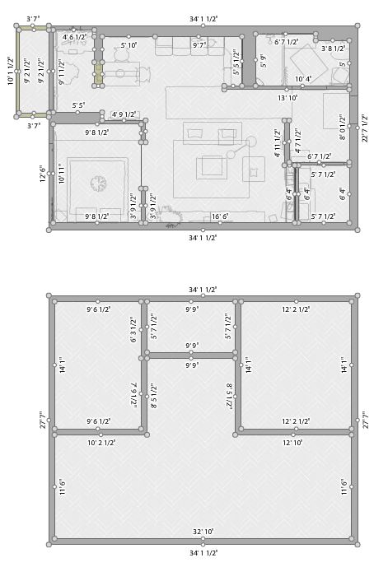
EXAMPLE:
Floor 2
Floor 1
REQUIREMENTS FOR EACH ROOM (Please make sure you meet these requirements):
Adding onto your bedroom connect a bathroom
- Bathroom
  - Toilet
  - Door
  - Window
  - Sink
  - Shower and/or tub
  - Mirror
  - Toilet paper
  - Wall and floor décor
  - Lighting
  - Flooring
  - Wall covering
  - Door
  - Decorations/plants/art work/ etc.
DUE: 2/20
- Guest bedroom (if you finish the first one before the due date, then make a second one.)
  - Bed
  - Dresser
  - At least 1 Door
  - At least 1 window
  - Closet/clothing storage of some sort (dresser/more cabinets/etc.)
  - At least 1 Desk
  - At least 1 Chair
  - Wall covering of some sort (paint, wallpaper, texture, etc.)
  - Floor covering of some sort (carpet, concrete, wood, grass, etc.)
  - Decorations on the wall of any sort
  - Some form of entertainment (computer, TV, radio, sound system, etc.)
  - Door
DUE: 3/6
- A laundry room area
  - Washing machine
  - Dryer
  - Sink
  - Counter top or table of some sort
  - Trash can or laundry basket
  - Lighting
  - Flooring
  - Wall covering
  - Door
  - Decorations/plants/art work/ etc.
  - At least one window per room on the outer walls
DUE: 3/8
- Kitchen
  - Stove
  - Fridge
  - Sink
  - Counters
  - (you are allowed to create an island)
  - Lighting
  - Trash can of some sort
  - Flooring
  - Wall covering
  - Door
  - Decorations/plants/art work/ etc.
  - At least one window per room on the outer walls
DUE: 3/14
- Dining Room
  - Table
  - Chairs
  - Decorations of some sort
  - Lighting
  - Flooring
  - Wall covering
  - Door
  - At least one window per room on the outer walls
DUE: 3/26
- Living-room area
  - Sitting area
  - Electronic entertainment
  - Coffee and/or side tables
  - Rug
  - Decorations of some sort
  - Lighting
  - Shelving/ Storage of some sort
  - Flooring
  - Wall covering
  - Door
  - At least one window per room on the outer walls
DUE: 3/29
- Office
  - Desk
  - Chair
  - Electronics of some sort
  - Decorations of some sort
  - Lighting
  - Flooring
  - Wall covering
  - Door
  - At least one window per room on the outer walls
DUE: 4/2
- Backyard:
  - Grass/rocks
  - Fence
  - Recreation items (bike, sports equipment, dining set, grill, sun bathing chairs, etc.)
  - Door
DUE: 4/5
Other basic requirements for a house:
- If 2 story NEED STAIRS somewhere
- Hallways
- A Front Entrance (door)
- A Back Entrance (door)
- At least 2 closets/areas for storage
  - Shelving
  - Lighting
If you have a second floor, make sure to have Stairs going up to that floor, and make sure the entrance to the second floor is not blocked by anything such as walls, furniture or doors.
When your house is complete you will be taking 3 screenshots of your home, the overall 2D Floor Plan, a 3 D Floor Plan Shot, and a screenshot of your favorite room in the house.
You will turn this assignment into Edmodo for grading.

OVERALL PROJECT DUE: 4/5

