Drawing Format Tools Tab
Icon | Tool Name | Section Name | Function of the tool
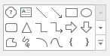
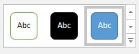
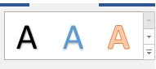
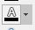
Picture Format Tools Tab
