Table Tools DESIGN Tab
Icon | Tool Name | Section Name | Function of the tool
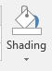
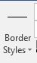
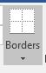
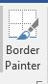
Table Tools LAYOUT Tab
